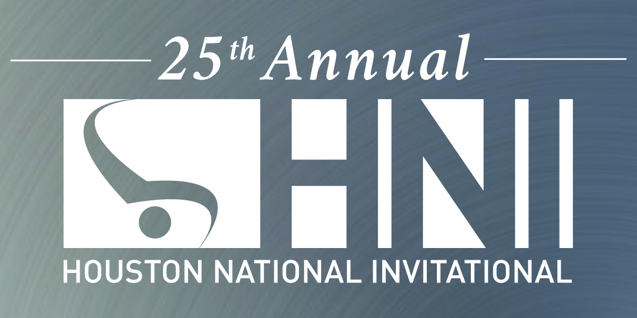

FINAL
2019 Men’s Competition Schedule

Thursday, January 31st
Open training, coaches must be present with athletes: 3:30 pm – 7pm

ALL SESSIONS WILL BE CAPITAL CUP FORMAT
Cross Judging (Like JO Nationals) for all sessions except Open Team Cup

Friday, February 1st

Session 1, Level 8 (12 yrs) and Level 9 (13 yrs)
Open stretch 8:00 am
Team introductions 8:25 am
Flight A Warm up and begin competition 8:35 am
Awards 12:00 pm

Session 2, Level 8 (13+), Level 9 (14, 15+ yrs)
Open stretch 12:15 pm
Team introductions 12:40 pm
Flight A Warm up and begin competition 12:50 pm
Awards 4:15 pm

Session 3, Open Team Cup (13 Teams)
Open stretch 4:40 pm (Athletes allowed in WU gym at 4:30)
Open Events Warmup 5:05-6:00 pm
Open Ceremonies 6:00-6:15 pm
1 Touch / Competition begins 6:20 pm
Awards 9:00 pm

2019 Men’s Competition Schedule

Saturday, February 2nd

Session 4, Level 7 (All), Lv. 8 (11 yrs)
Open stretch 7:50 am
Team introductions 8:15 am
Flight A Warm up and begin competition 8:20 am
Awards 11:30 am

Session 5, Level 10 (15, 16 yrs)
Open stretch 11:45 am
Team introductions 12:10 pm
Flight A Warm up and begin competition 12:20 pm
Awards 4:45 pm

Session 6, Sr. Elites & Level 10 (17-19 yrs)
Open stretch 5:15 pm
Team introductions 5:25 pm
Flight A Warm up and begin competition 5:35 pm
Awards 9:30 pm

Saturday Night: Great coaches party in the Holiday Inn – Next to NRG Center! Party begins at

Men’s Competition Schedule

Sunday, February 3rd

Session 7, Level 6 (10,11,12+ yrs) Lv. JD (All)
Open stretch 8:00am
Team introductions 8:25am
Flight A Warm up and begin competition 8:35am
Awards 11:45 am

Session 8, Level 5 (9,10,11+ yrs) Lv. 6 (8,9 yrs.)
Open stretch 12:00 pm
Team introductions 12:25 pm
Flight A Warm up and begin competition 12:35 pm
Awards 3:45 pm

Session 9, Level 4 (6,7,8,9+ yrs) Lv. 5 (7,8 yrs)
Open stretch 4:00 pm
Team introductions 4:25 pm
Flight A Warm up and begin competition 4:35 pm
Awards 7:00 pm

